Attitudes and Persuasive Communications

Disusun oleh :
Ifantri Julio F. P 2021-669
Dwi Saputra Wijaya 2021-677
M. izzudin khoirulloh 2021-699
M. Reza Fatoni 2021-704

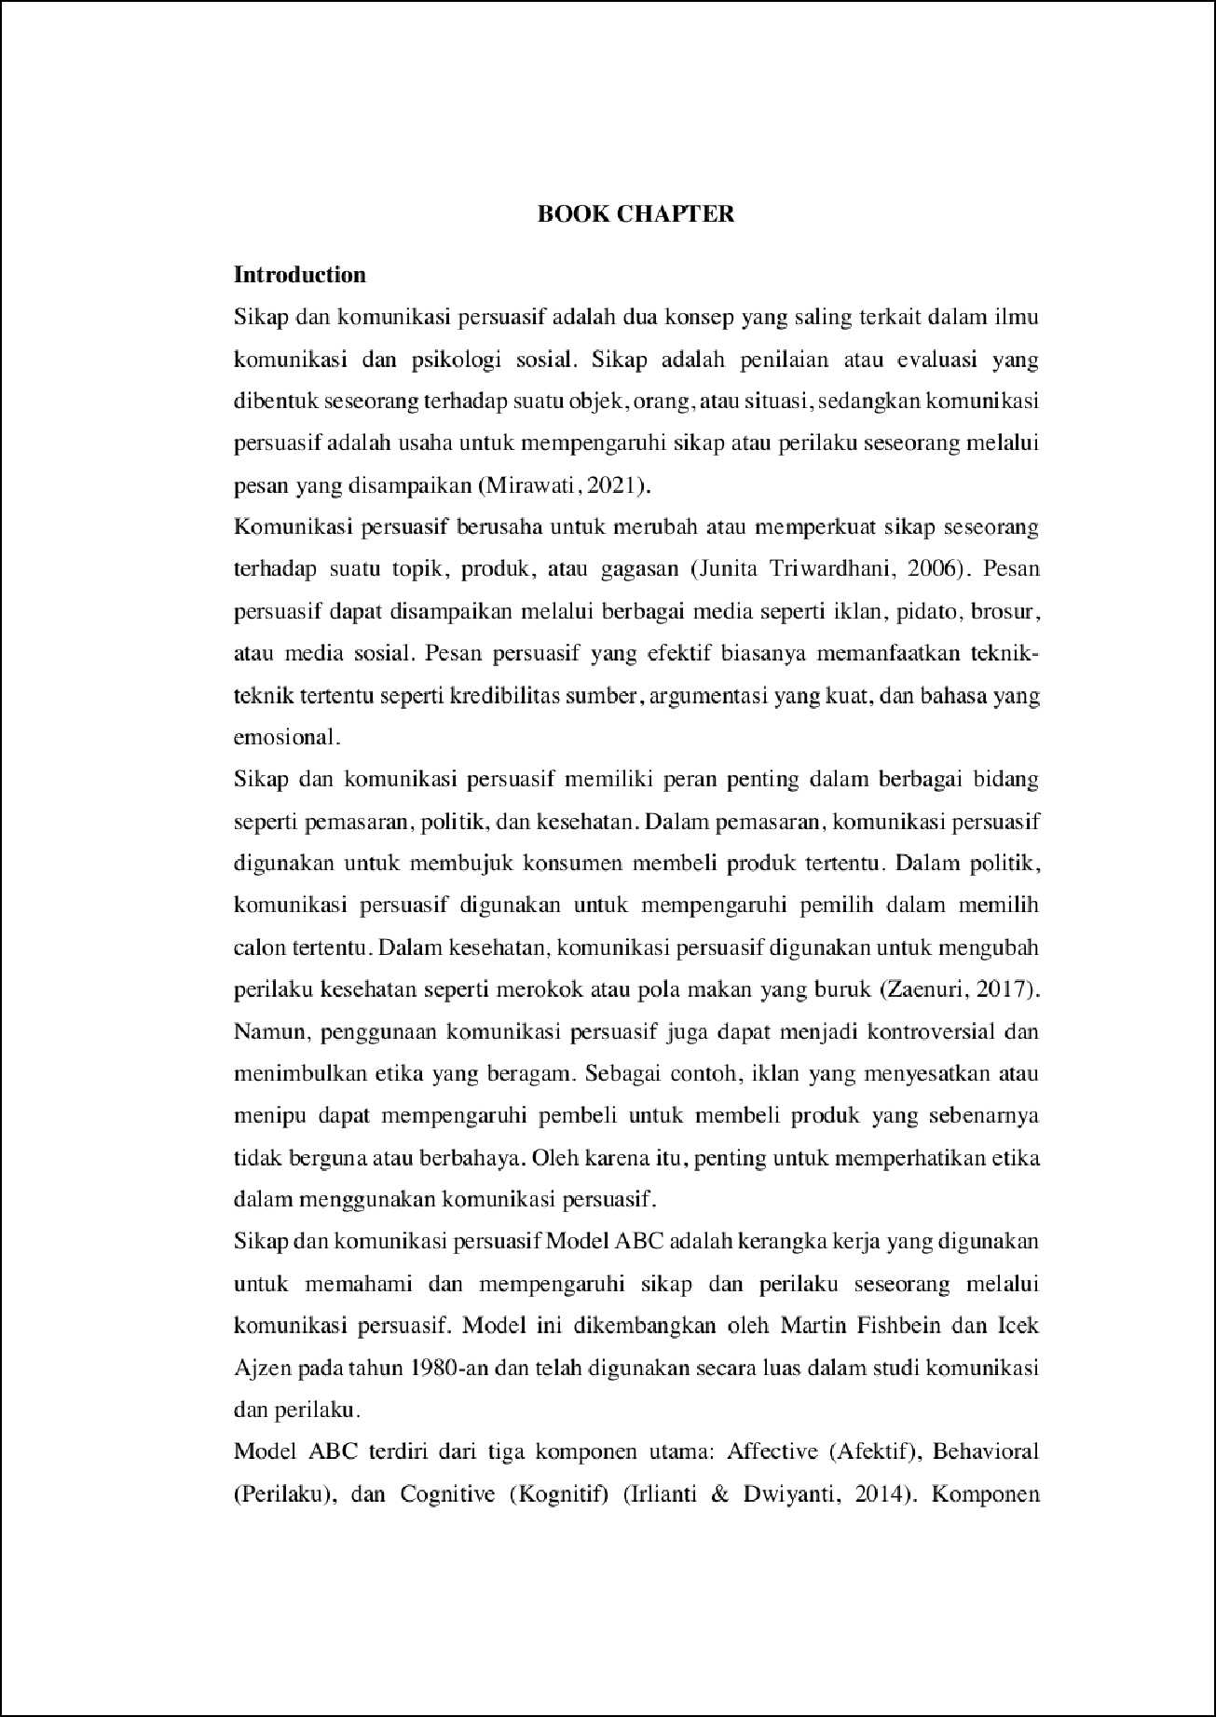

24

12

31

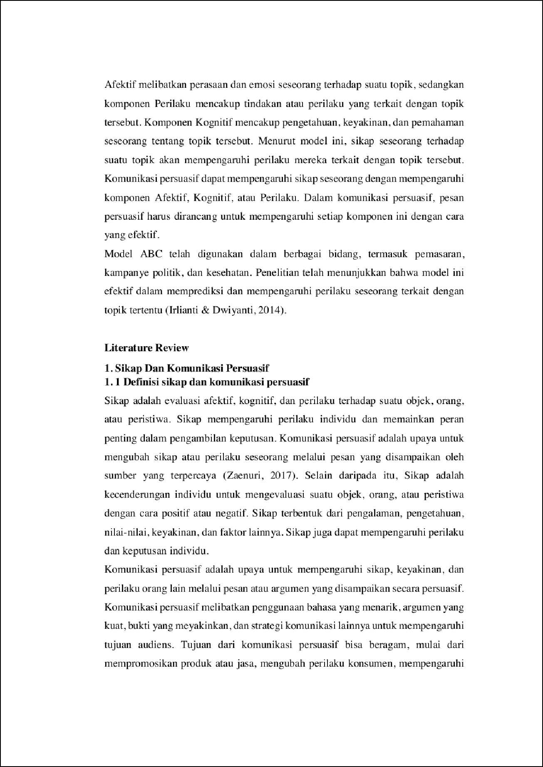

23

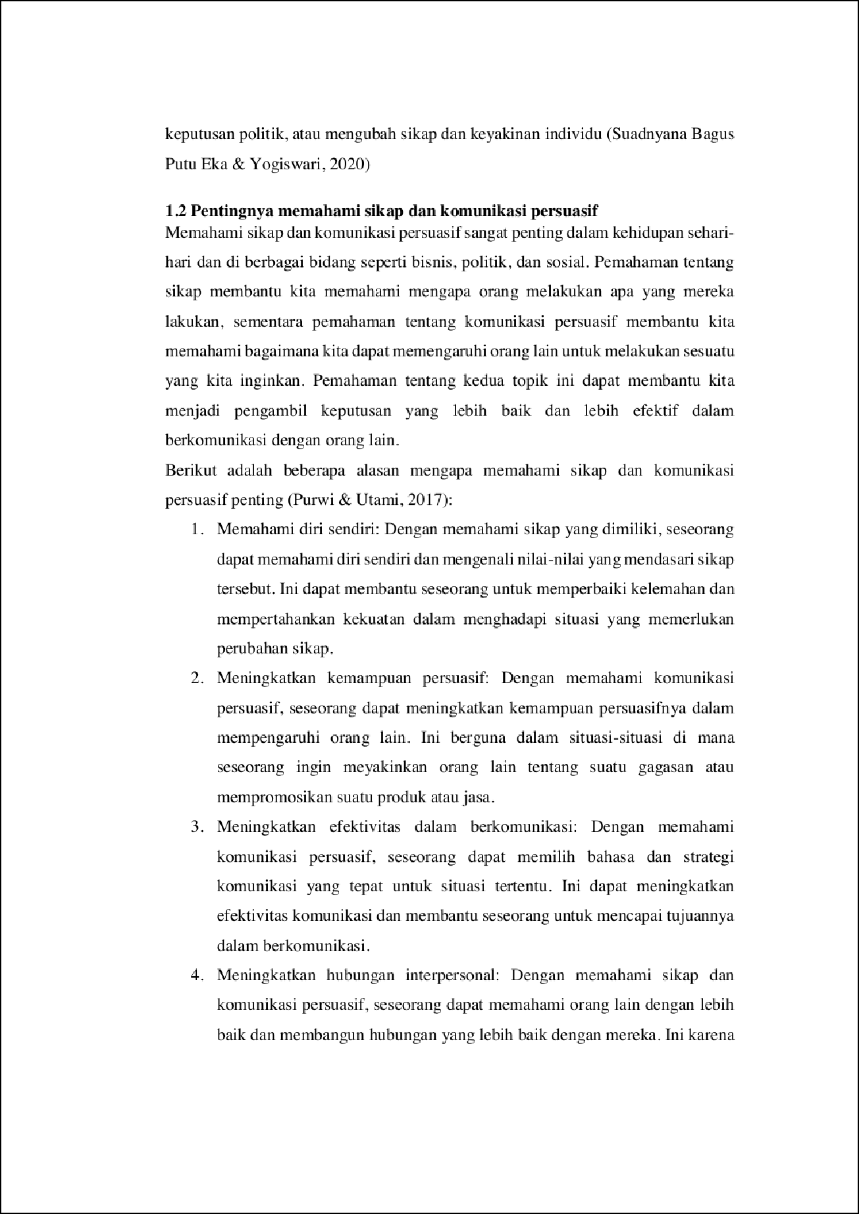

17

13

25

14

20

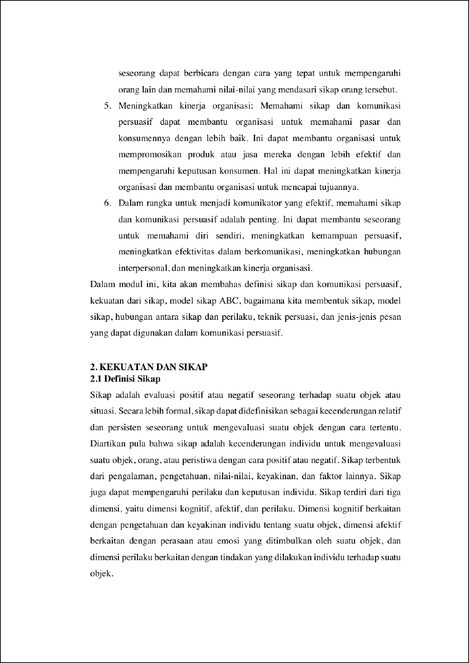

3

5

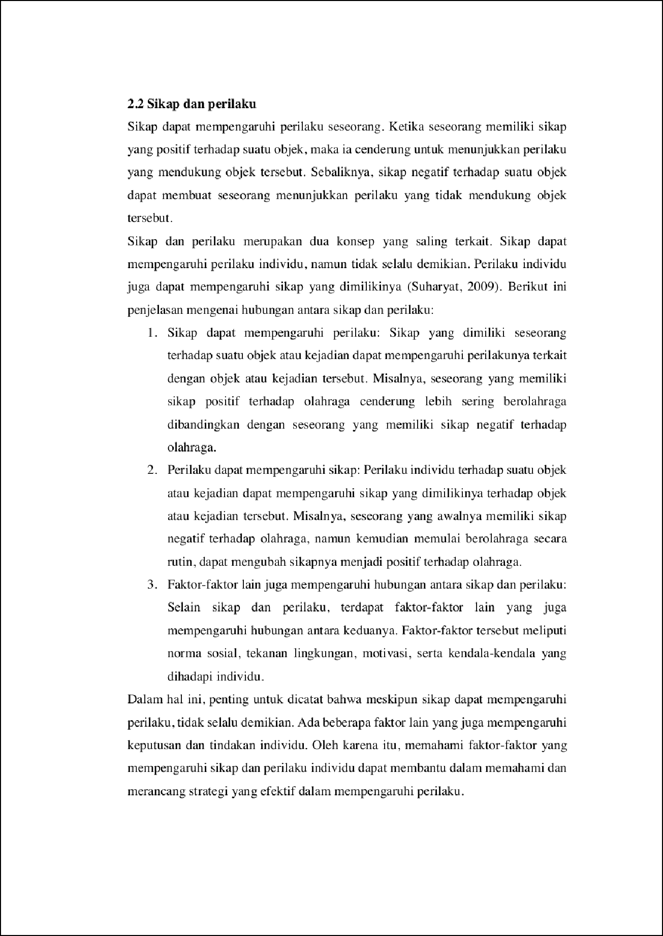

8

27

16

28

7

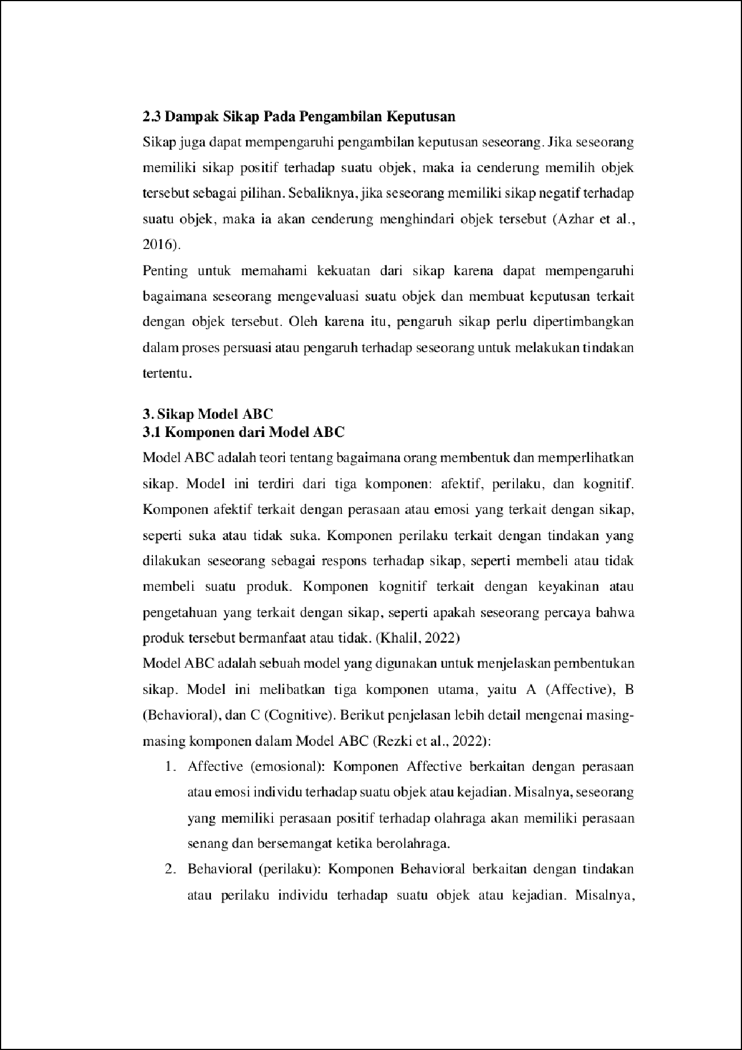

1

10

4

4

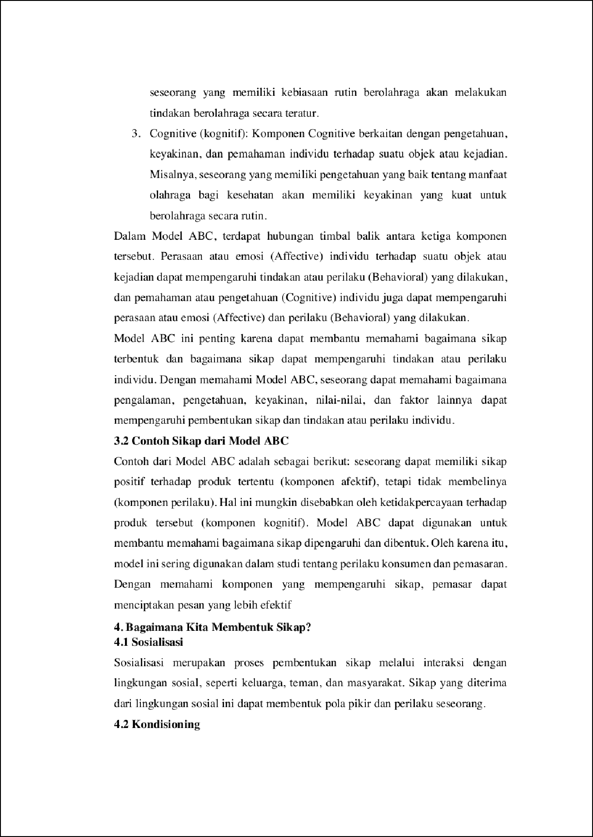

1

2

26

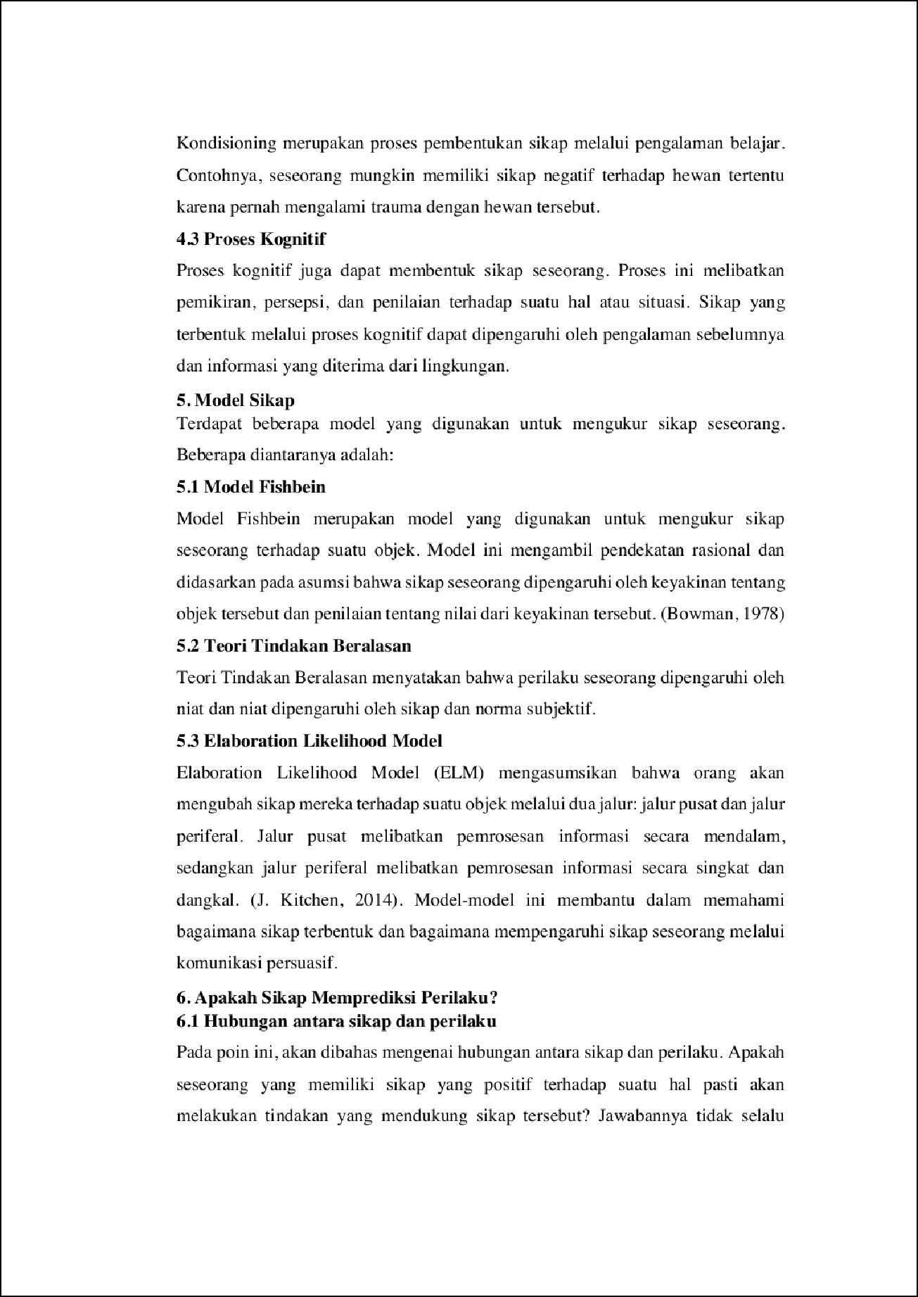

6

30

11

29

5

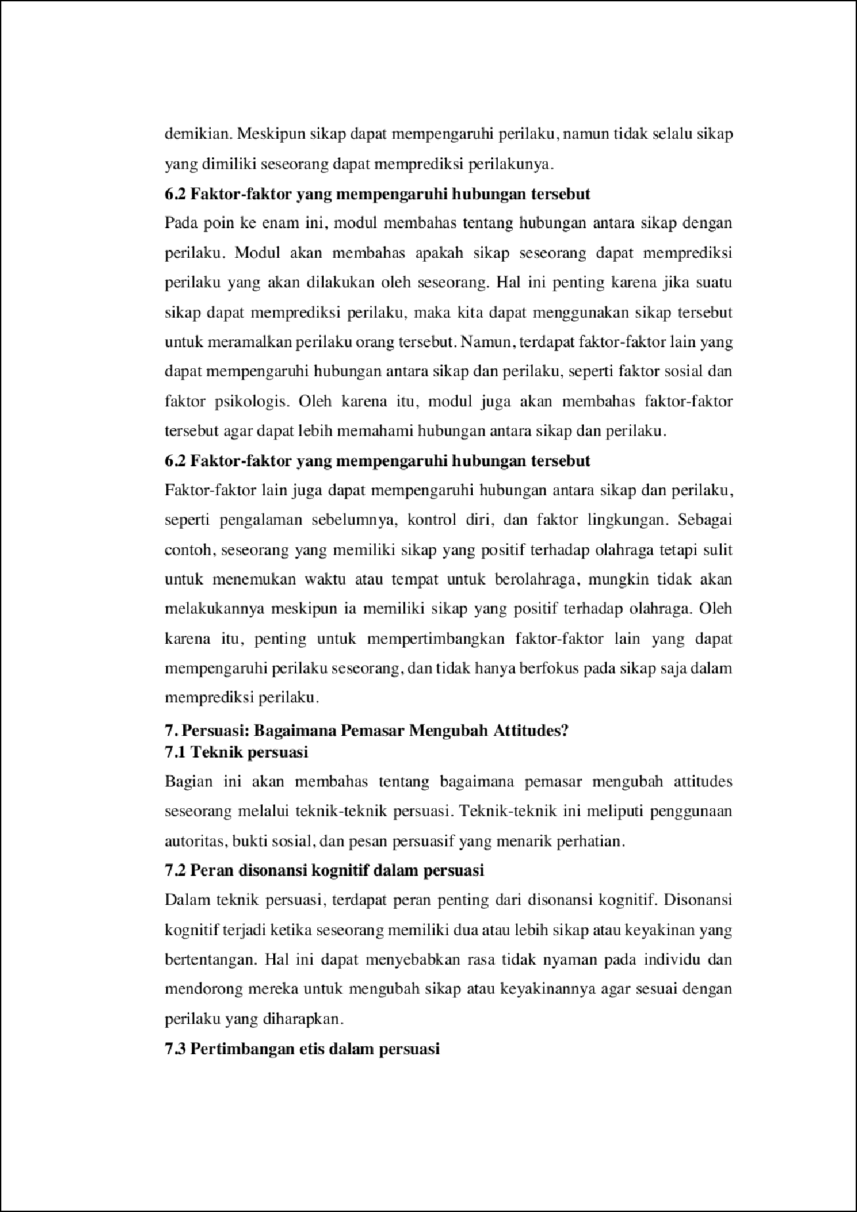

7

21

3

19

1

22

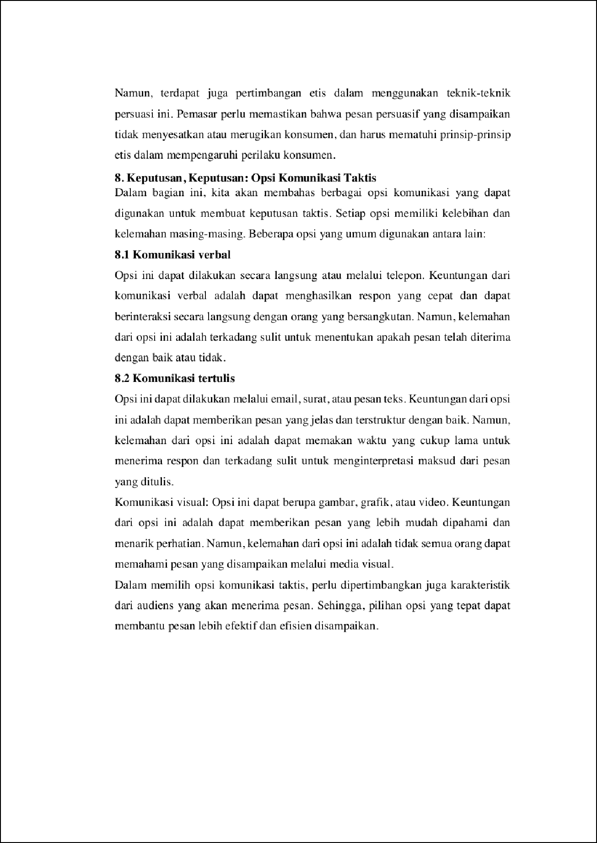

2

2

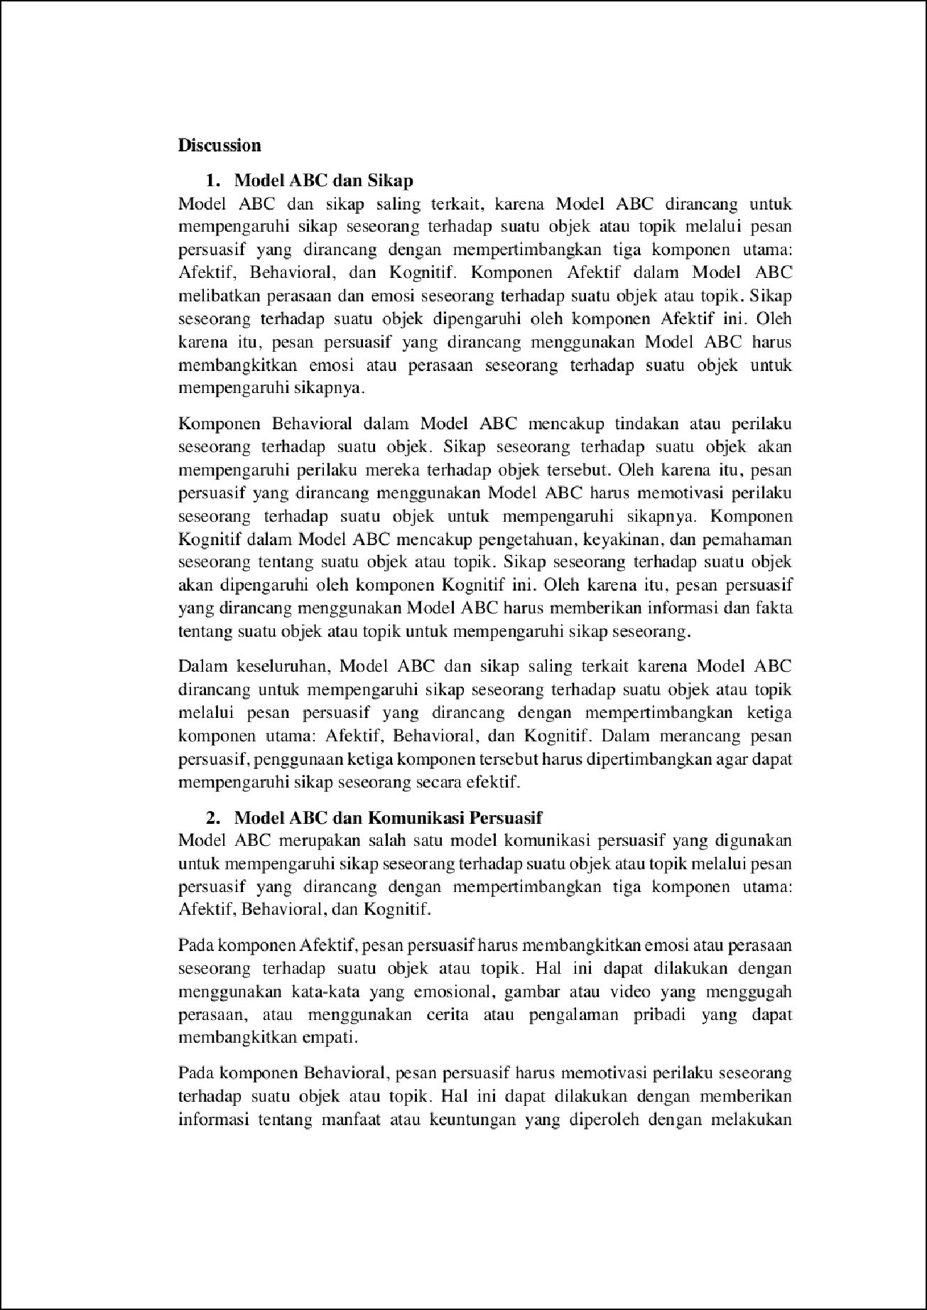

4

18

9

6

15

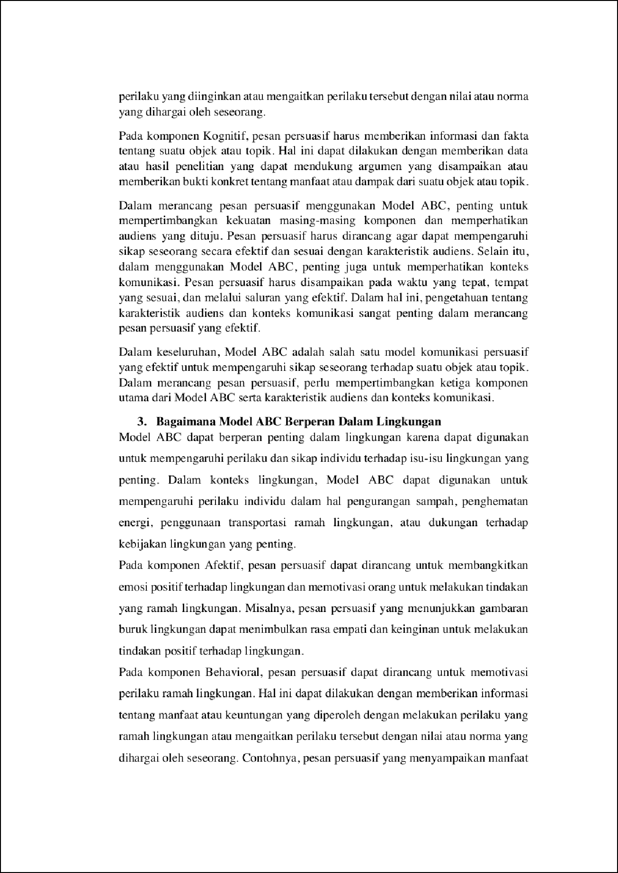

1

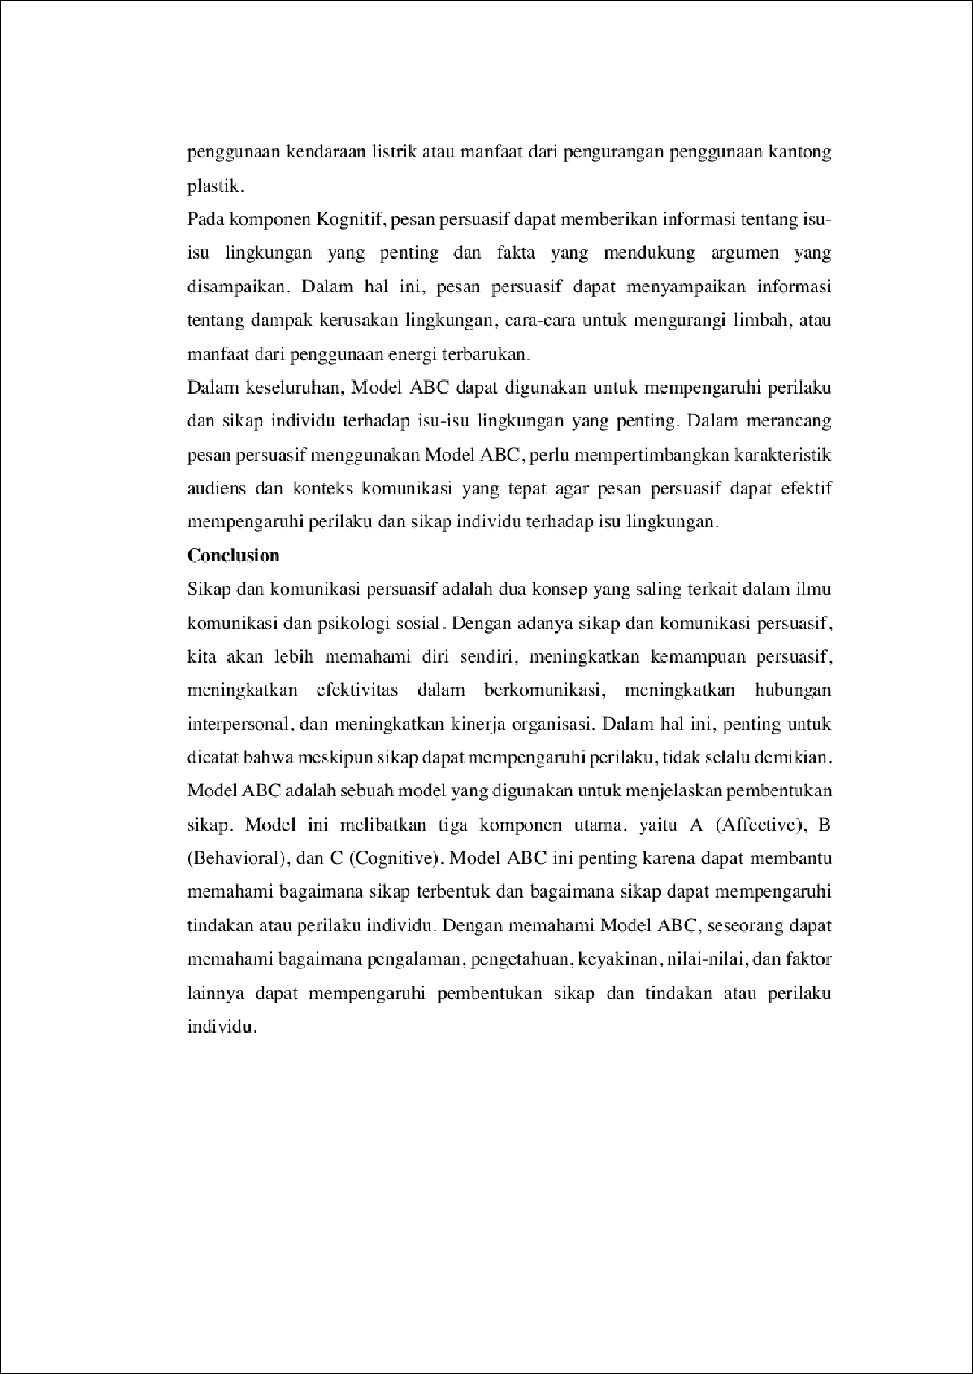

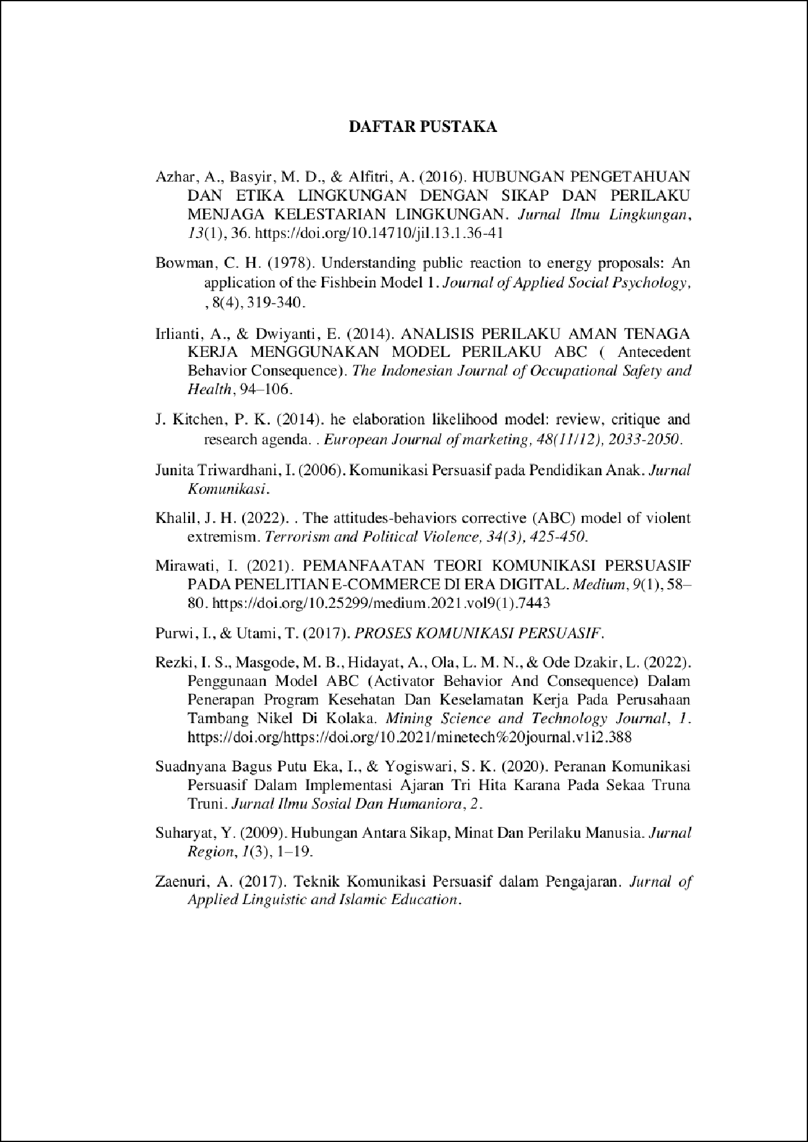

MODUL_2.pdf
ORIGINALITY REPORT
10

%
SIMILARITY INDEX

10%
INTERNET SOURCES

2%
PUBLICATIONS

0%
STUDENT PAPERS

PRIMARY SOURCES

www.scribd.com
1
Internet Source

pt.scribd.com
2
Internet Source

repository.unhas.ac.id
3
Internet Source

eprints.walisongo.ac.id
4
Internet Source

dinantip.wordpress.com
5
Internet Source

wahanamhs.blogspot.com
6
Internet Source

id.123dok.com
7
Internet Source

digilib.unila.ac.id
8
Internet Source

9 Sri Rahayu. "Hubungan Pengetahuan dan Sikap dengan Perilaku Caring Perawat di Rumah Sakit", Faletehan Health Journal, 2018
1%
1%
1%
1%
<1%
<1%
<1%
<1%
<1%

10

11

12

13

14

15

16

17

18

19

20

21
Publication

eprints.uns.ac.id
Internet Source

konsultasiskripsi.com
Internet Source

library.binus.ac.id
Internet Source

rosdiananatsir.wordpress.com
Internet Source

syafaruddin.blog.uma.ac.id
Internet Source

thesis.binus.ac.id
Internet Source

aﬁaanwas.blogspot.com
Internet Source

belajargoo19.blogspot.com
Internet Source

docobook.com
Internet Source

ejournal.ipdn.ac.id
Internet Source

jurnal.unissula.ac.id
Internet Source

repository.trisakti.ac.id
<1%
<1%
<1%
<1%
<1%
<1%
<1%
<1%
<1%
<1%
<1%

22

23

24

25

26

27

28

29

30
Internet Source

www.jinanjinkui.com
Internet Source

Rizky Oktarina Costa. "Pengaruh Komunikasi Persuasif Guru terhadap Motivasi Belajar Peserta Didik Sekolah Alam Tunas Mulia", EDUKATIF : JURNAL ILMU PENDIDIKAN, 2022
Publication

adoc.pub
Internet Source

corcheo2.rssing.com
Internet Source

doku.pub
Internet Source

repository.uinjkt.ac.id
Internet Source

www.coursehero.com
Internet Source

www.researchgate.net
Internet Source

Elvira Hertika, Saiful Saiful, Eddy Suranta. "DETERMINAN MINAT NASABAH DALAM MEMILIH PEMBIAYAAN SYARIAH", JURNAL FAIRNESS, 2021
Publication
<1%
<1%
<1%

<1%
<1%
<1%
<1%
<1%
<1%
<1%

31
tugasdenny.wordpress.com
Internet Source
<1%

Exclude quotes Oﬀ Exclude bibliography On
Exclude matches Oﬀ

